ACADEMIA INTERNACIONAL DE DAVID


TECHNOLOGY
SUMMATIVE WORKSHOP # 2

NAME: __________________________ DATE: _______________________ 3rd ^{Grade}: A B C
TEACHER: EDGAR PITTY
INSTRUCTIONS: READ THE WORKSHOP CAREFULLY. DO NOT USE PEN. DOUBLE ANSWERS OR CROSS OUTS ARE NOT VALID. RETURN THE ASSIGNMENT AFTER YOU FINISH OR BEFORE THE END OF THE CLASS.
Name and date: 1 pts. |  | Follow Instructions: 1 pts.
Order: 1 pts. |  | Correct use of tools: 2 pts.
CONTENT: 30 pts. |  | TOTAL: 35 pts.

Part I: Identify the part of the robot with the correct COLOR. 2 pts. each 10 pts. total.

Motor: Orange | Light Sensor: Red | Controller: Green | Ultrasonic sensor: blue | Color sensor: Yellow

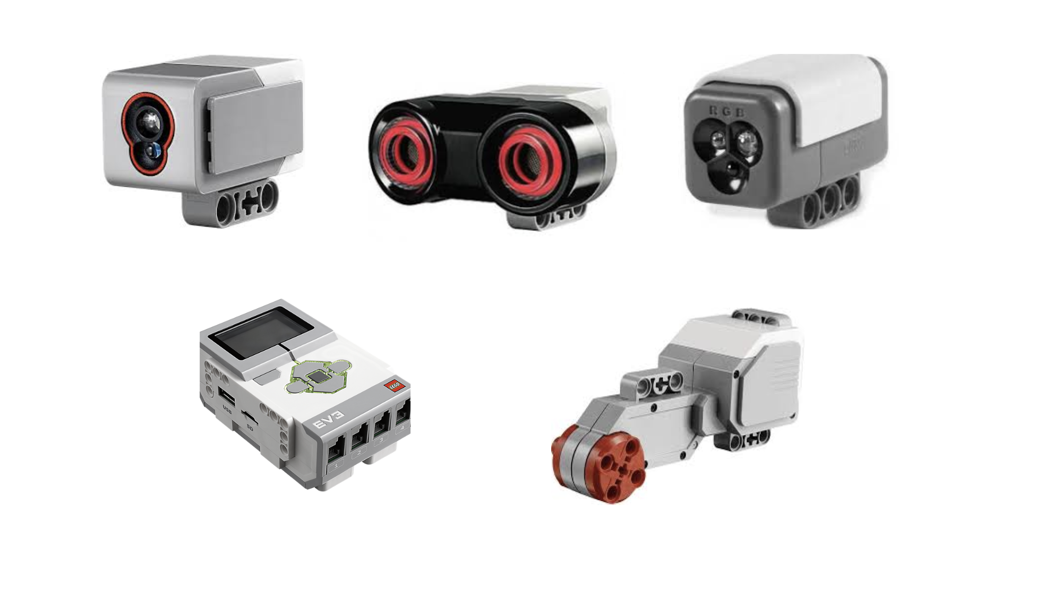

Part II: Choose with a circle the correct part of the robot. 2pts each, 10 pts. total.
Choose the correct answer.

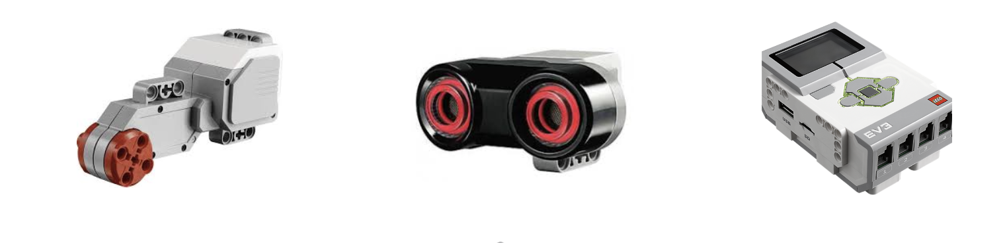
- Which one is the sensor?

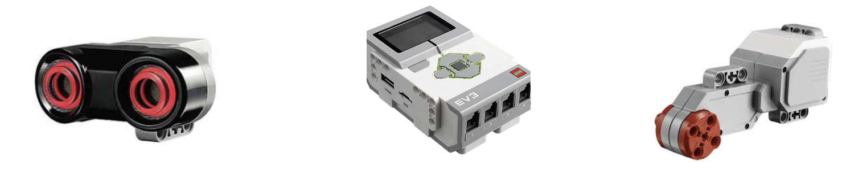
- Which one is the motor?

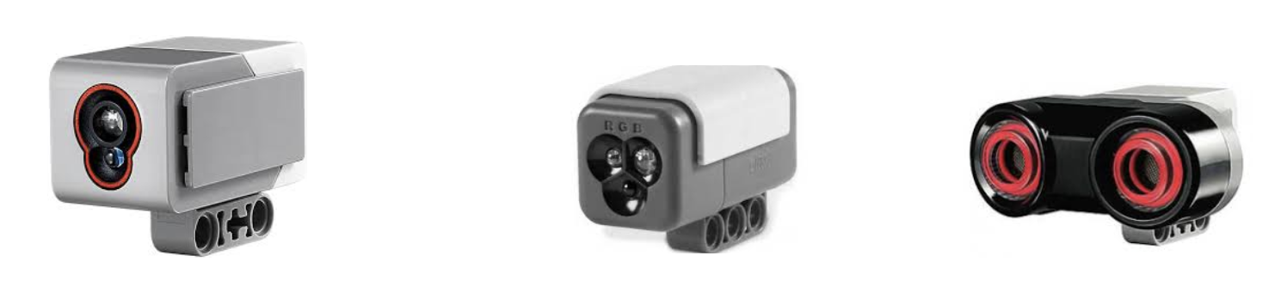
- Which one is the light sensor?

- Which one is the controller?
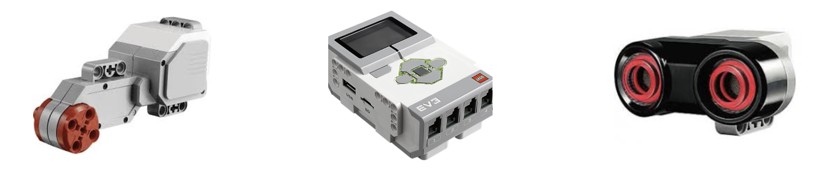
- Which one is the color sensor?
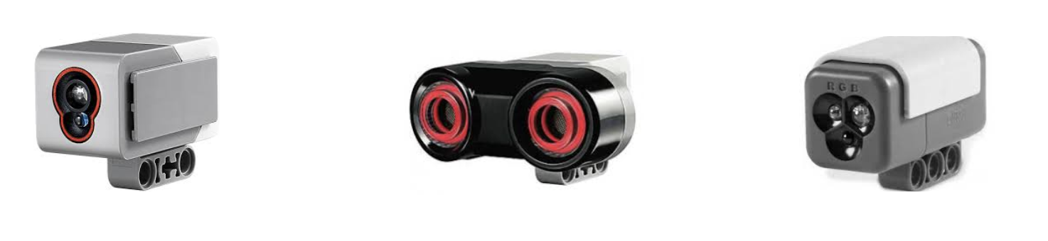

Part III. Complete the following names of the parts of the robot. 2 pts. each, 10 pts. total.
